Hiding the conditions

* If the eye is SHUT then students who do not meet that part of the condition will not see the activity at all.
* If the eye is OPEN the students who do not meet that part of the condition will see the activity but it will be greyed out and have information about why they can't access it yet.

The shut eye takes precedence. For example, you could have 2 conditions, one based on date (with eye shut) and one based on completing a previous activity (with eye open). That way, the activity will not appear at all until the date; then it will appear, but tell you that you need to complete the other activity; then when you complete the other activity you can access it.

For OR and NOT AND type conditions, you only get a single eye icon instead of one for each condition

[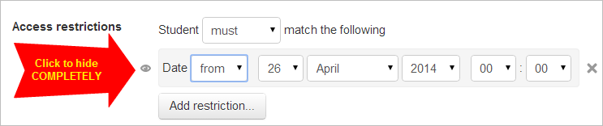](https://docs.moodle.org/31/en/File:daterestrict1.png)